**DAILY ONLINE ACTIVITIES SUMMARY**

|  |  |  |  |  |  |  |  |  |
| --- | --- | --- | --- | --- | --- | --- | --- | --- |
| **Date:** | **08-06-2020** | | | | | **Name:** | **Apoorva H P** | |
| **Sem & Sec** | **VI A** | | | | | **USN:** | **4AL17CS011** | |
| **Online Test Summary** | | | | | | | | |
| **Subject** | | **CNSC IA Test** | | | | | | |
| **Max. Marks** | | **60** | | **Score** | | | **23** | |
| **Certification Course Summary** | | | | | | | | |
| **Course** | **Introduction to Ethical hacking** | | | | | | | |
| **Certificate Provider** | | | **Great Learning** | | **Duration** | | | **4hr** |
| **Coding Challenges** | | | | | | | | |
| **Problem Statement:**  1.Python Program to Copy the Contents of One File into Another  2. Python Program to Check Whether a String is a Palindrome or not Using Recursion | | | | | | | | |
| **Status: Completed** | | | | | | | | |
| **Uploaded the report in GitHub** | | | | | **Yes** | | | |
| **If yes Repository name** | | | | | <https://github.com/ashaapoorva/online-coding-and-certification-course> | | | |
| **Uploaded the report in slack** | | | | | **Yes** | | | |

**Online test Detail:**

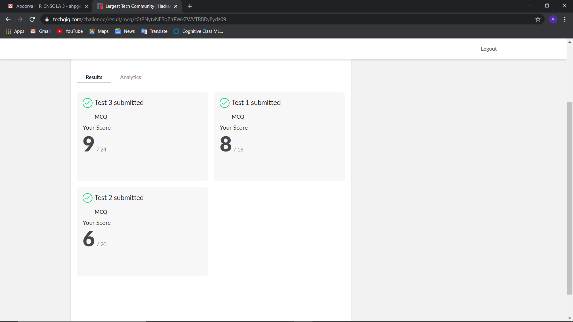

**Online Certification Details**

Modules completed:

-Attempted quiz

-claimed certificate

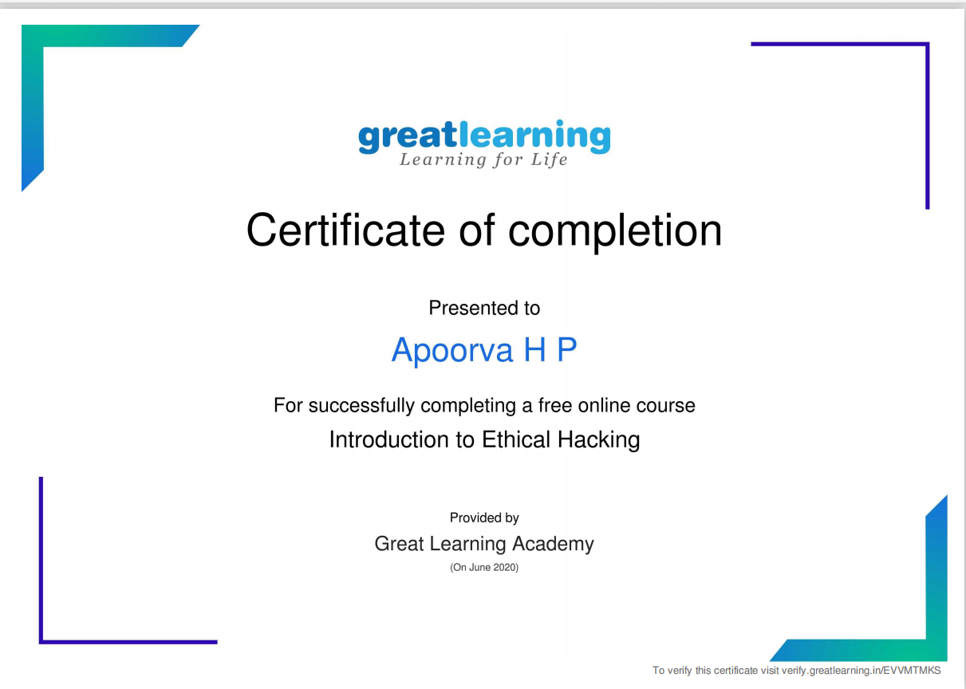

**Coding Challenge Details**

1. Python Program to Copy the Contents of One File into Another

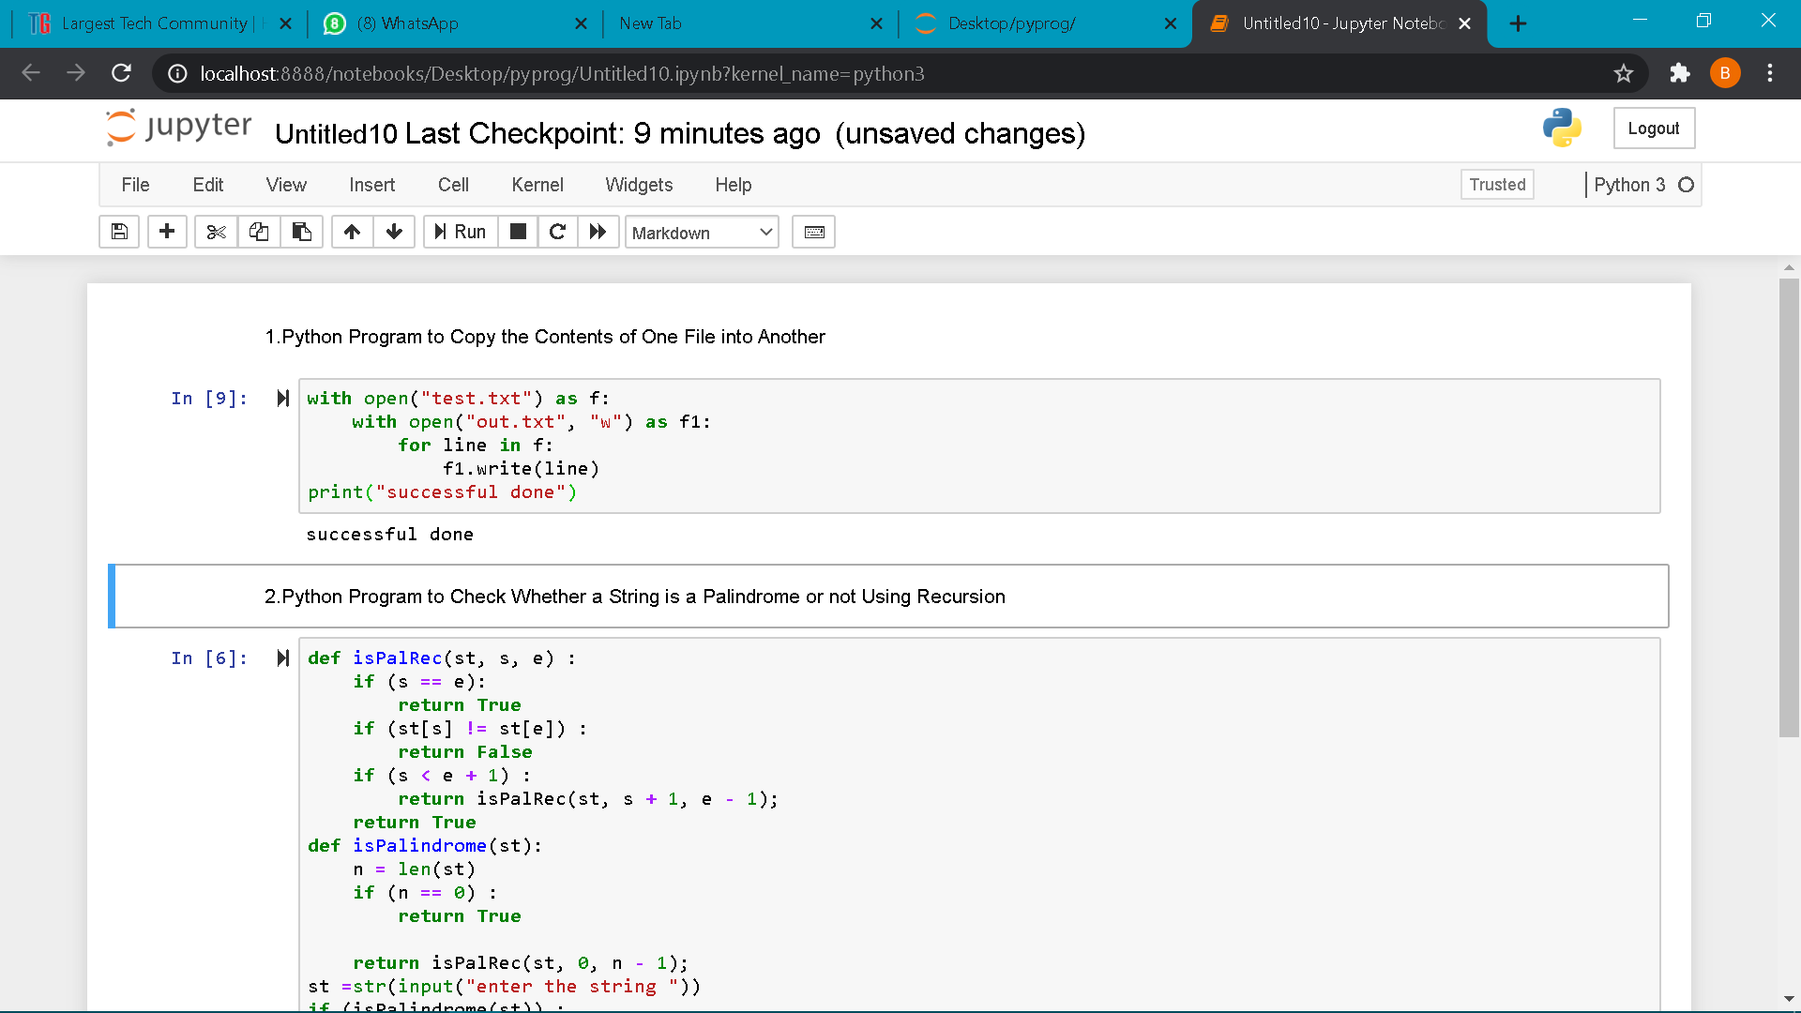

1. Python Program to Check Whether a String is a Palindrome or not Using Recursion

